Hypothesis 1: Different Characters

Hypothesis: The difference in characters that were used resulted in different factors.
Result: To test this, using Dweck’s raw data, we kept the same item numbers and decreased the number of characters from the original 21 to the 3 that Malle used. This resulted in a difference in item loadings grouping with different factors. However, even if Dweck had used the same characters as Malle, Dweck’s results wouldn’t have been any closer to Malle’s. So, we cannot conclude that the difference between the characters that Dweck and Malle used was a factor in different factors.

PCA with 3 Characters and 40 Items | PCA with 21 Characters and 40 Items
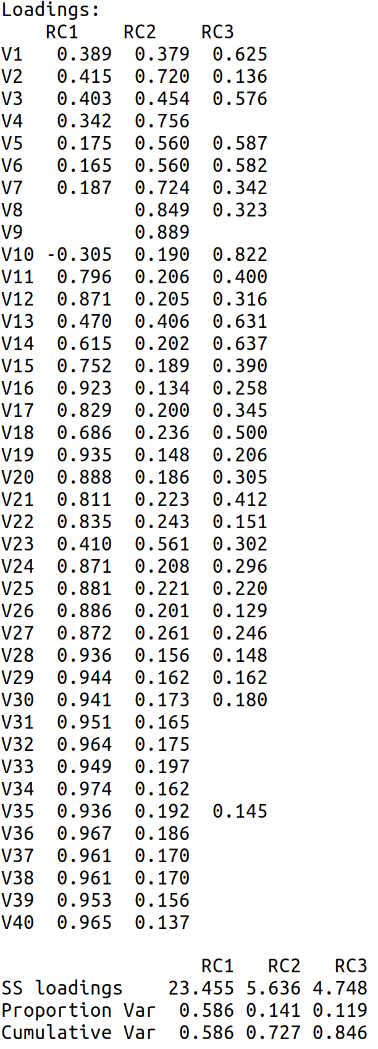 | 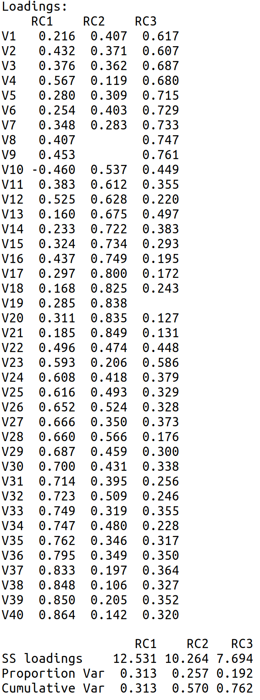

Difference between PCA loadings for 3 characters and 40 items and 21 characters and 40 items

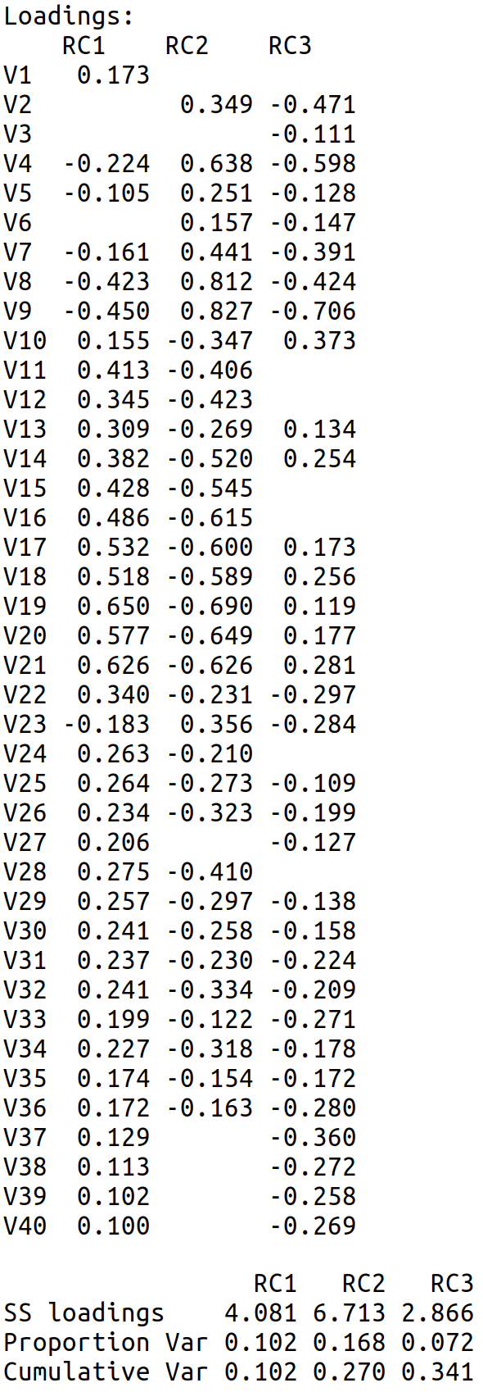

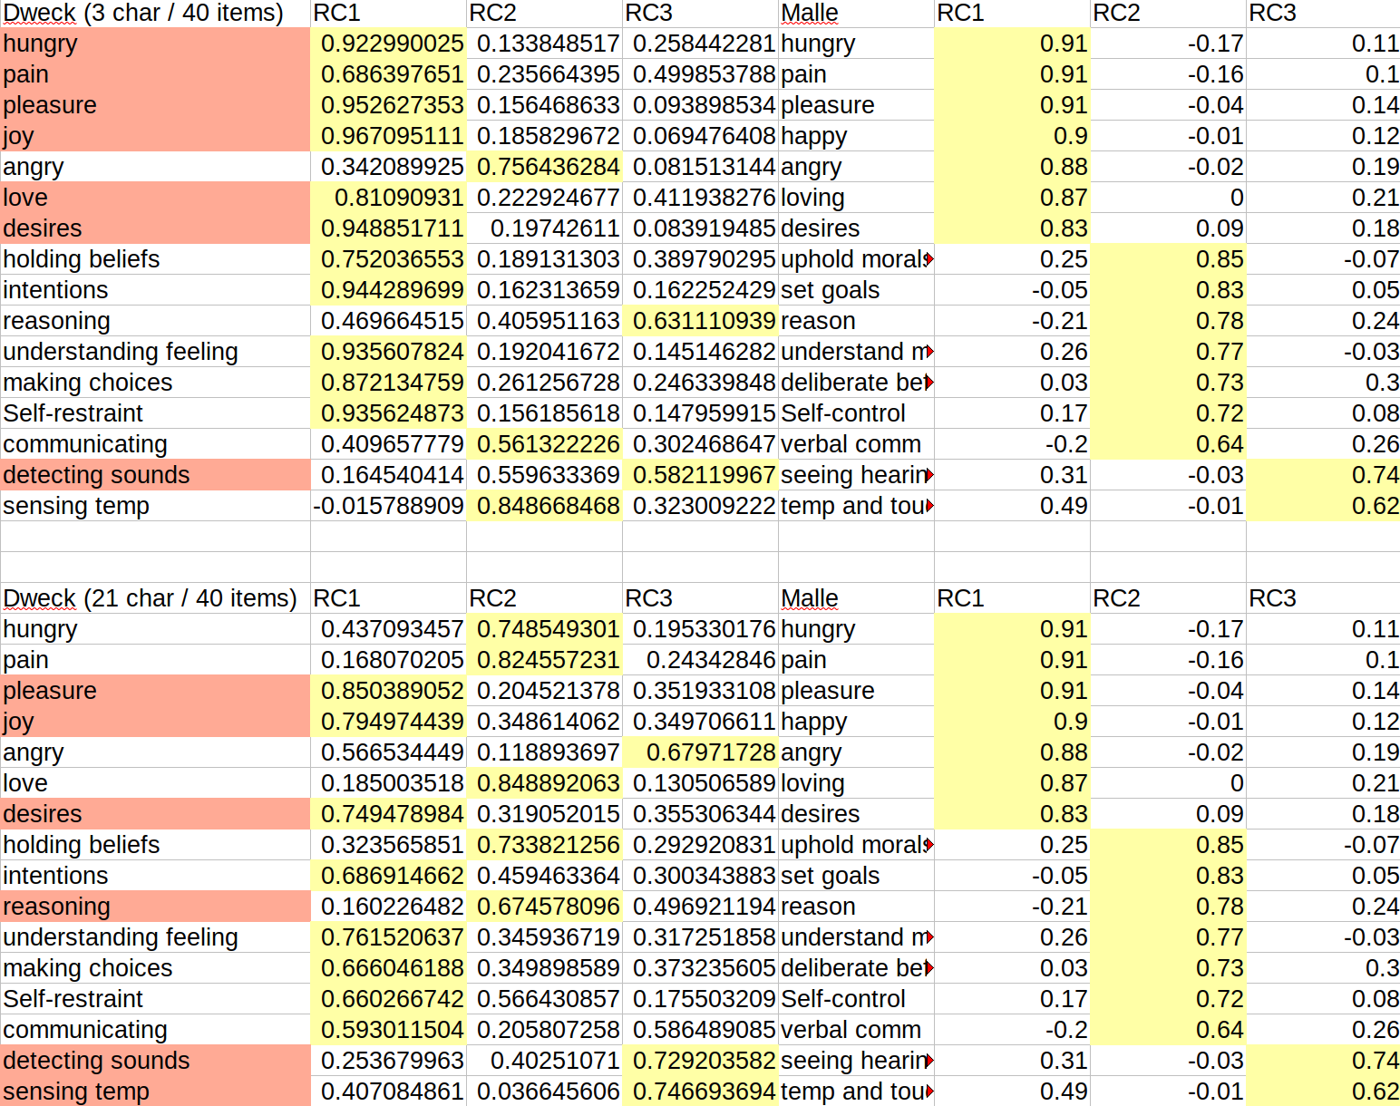
Items highlighted in red are different under the assumption that the factors are the same across Dweck and Malle
While going from 21 characters to 3 did change Dweck’s factors, it did not make them more similar to Malle’s factors.

Hypothesis 2: Different Data
Hypothesis: The data collected was different, resulting in different conclusions
Result: To test this, for the 16 items and 3 characters Dweck and Malle had in common, we compared the distribution. WRITE CONCLUSION HERE.
Evidence:
- compareDweckMalleRaw.R compared the minimum, maximum, mean, median, and standard deviation for datasets of Malle and Dweck in which the characters and items were similar.

Hypothesis 3: Factors are not different
Hypothesis: The loadings for Malle and Dweck are not actually different.
Result: To test this, we ran a PCA on the characters and items that Dweck and Malle had in common, Then we did a qualitative comparison in which the loadings for each item and factor were matched across Dweck and Malle. WRITE CONCLUSION HERE.
Evidence:
- compareDweckMalle.R compared the item loadings for each of the three factors across Dweck and Malle

Hypothesis 4: Different Items
Hypothesis: The difference in items resulted in different factors for Dweck and Malle.
Result. To test this, for Malle and Dweck separately, a PCA was run on both their original data, and only the data they had in common. Then, we qualitatively compared their factors’ differences. When running a PCA on Dweck’s data with only the items in common with Malle, Dweck’s items fell under the same factors as Malle’s items. This suggests that if Dweck and Malle had used the same items, they would have gotten similar results.

PCA with 21 Characters and 16 Items | PCA with 21 Characters and 40 Items
